**We Live In Time Review**

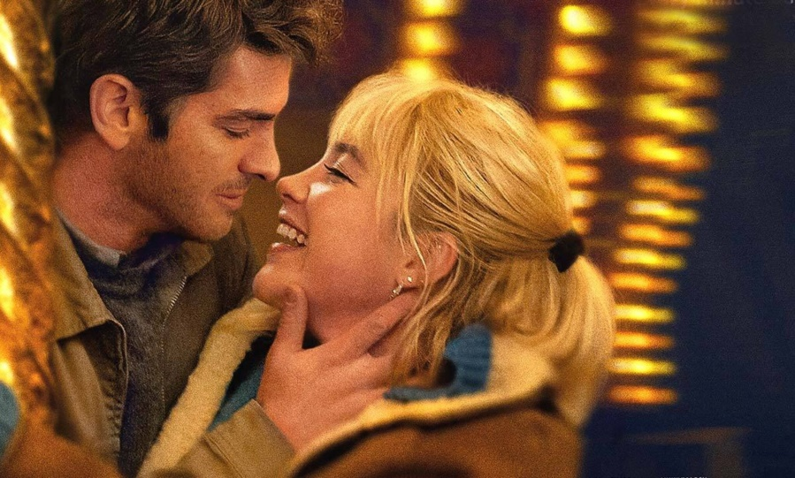

What is the first movie of the year that I’ve seen proves to be a delightful treat that warms the heart and I couldn’t help but be enamoured by. Directed by John Crowley, We Live In Time is a romantic drama that spans over several years, told non-chronologically and tells the story of a Weetabix agent named Tobias (played by Andrew Garfield) who falls in love with a former figure-skater turned head chef (Almut played by Florence Pugh). Their happiness is cut short however, when they find out that she has ovarian cancer. Hesitant to undergo treatment, she tells Tobias that she would rather have six amazing months of joy as opposed to twelve months of agony and pain only for it to be for nought.

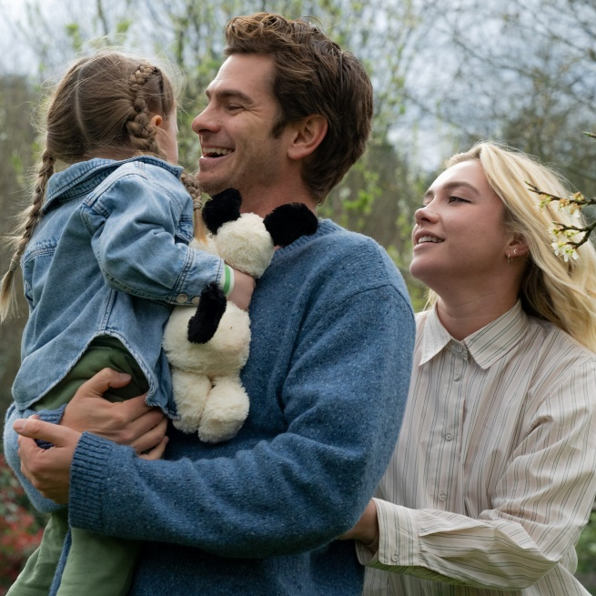The emotional core of the story is delivered through Tobias’ perspective, who is forced to watch as the woman he loves suffers, knowing that he can only do as she asks of him, to make her last few months ones of joy. Andrew Garfield gives off a stunning performance befitting of the type of male character not typically seen in films. He wears his emotions on his sleeve and is seen to be clearly vulnerable, a brilliant trait that many men today still see as a weakness. Likewise, Florence Pugh plays Almut with a mix of intensity and vulnerability. She is a character who doesn’t want to be looked down on just because of her condition, and whereas Tobias shows his emotions plainly, Almut’s is more subdued. Initially, she tells him that she does not want to have a child, which crushes Tobias’ hopes. Upon receiving her cancer diagnosis however, she changes her mind. From then on, the strength Almut portrays is derived from wanting to show their daughter (played by Grace Delaney) a mother she could be proud of.

The structure of the story as mentioned before is told out of order. I profess to being somewhat ambivalent in regards to how I felt about this. I’m reminded of another movie from last year, *Challengers*, which adopted this same approach of storytelling, jumping back and forth through time. I feel this technique was adopted in a much more effective way there, in part due to the hairstyles and costume design helping to differentiate the more colourful and wild college days from the graying and slightly gloomy life of adulthood. Here there is little distinction until about two-thirds of the way through the story when it becomes quite clear what the most recent events are.

On the other hand, there are moments of surprise when the expectations of the audience are subverted due to the structure of the movie. In one scene earlier on in the film, Tobias walks out onto the highway in nothing but a bathrobe is run over by a car. We then find out that it was Almut’s car that he hit and that was how they initially met. This introduces a bit of comedy and whimsy into the film. While I’m not entirely sure the film needed to be told non-linearly, I do appreciate that it gives us something different from the conventional story of two lovers who seem perfect for each other and nothing seems like it could go wrong slowly spiralling into things going wrong. We are shown from the start a mixture of the good and bad of their relationship, and because of that it very much feels like a normal relationship rather than a fairy tale romance.

If I had to pay tribute to one of my favourite moments in the movie—and I believe it’s a scene I will never forget – it is the scene in which Almut gives birth. The fireworks that pop off towards the scene’s end and the massive traffic jam at the scene’s beginning gives us indication as to the possible date of their daughter’s day of birth, likely New Year’s Eve. This scene in particular perfectly captures the joy of watching films—being put into a bizarre, even comical situation and watching as the characters react to it. It was a beautiful moment in which even the side characters, two employees working as a petrol station (Nikhil Parmar and Kerry Godliman) whom haven’t been seen up to this point in the movie, are roped into a situation they couldn’t have possibly imagined. It was humorous, tense and ultimately sweet all woven together in a masterful way.

In the end *We Live In Time* is a bittersweet, heartfelt film that explores the joys that one can experience even in pain. That just for a brief moment in their lives, so much could be accomplished; so many emotions felt. It is a powerful reminder of living to enjoy the emotions of the here and now. With fantastic chemistry from its leads, a story that keeps you hooked from start to finish and many memorable moments in between, this is the perfect romance story to kick off 2025. Hearing Andrew Garfield and Florence Pugh act with their natural accents as well was fantastic too. They should do more of that.

4/5

*We Live In Time was released 1st January 2025 in UK cinemas.*

*Written by*

*Jermain Dunkley*